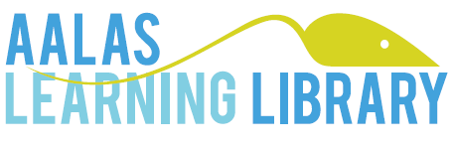

**Navigation Hints for using AALAS Learning Library (ALL)**

AALAS Learning Library (ALL) is the University of Virginia’s new online learning platform. ALL replaced the former LATA modules with the most current information with an enhanced learning experience.

ALL has numerous functions embedded in their website to help you navigate through modules and their online training module offerings.

* ALL modules are called “**courses**” and each course is made up of a series of “**lessons**.” Lessons may consist of *several pages*. You will need to advance through every page of each lesson in order to complete the course and reach the required assessment at the end.
* 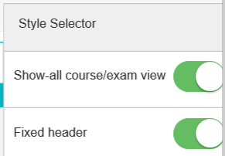In order to reduce the number of clicks necessary to advance through each lesson page, you *should* adjust the **Style Selector** settings to the “Show-all course/exam view” by sliding the toggle button to green. The **Settings** button is always located in the upper right side portion of the screen. After selected, you will only need to click through each lesson of the course.

Settings button to adjust the Style Selector

* View ALL modules in your preferred language. The Google Translate tool allows you the option of translating the website text. This button is always located in the lower left corner of the screen.
* 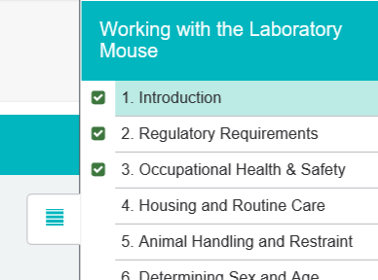Navigate to a specific section of a module using the navigation button. This button is always located in the upper right portion of the screen and can be opened or collapsed at any time. Green check marks will appear on completed lessons within a course.

Navigation button

* 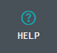The “Help” button is located at the top right of the screen at all times.
  + A video tour of the ALL website is available in the Help Center. *Some of the features are NOT applicable to your account through UVA*.
  + “My Account” - Contains ALL’s own set of Frequently Asked Questions.

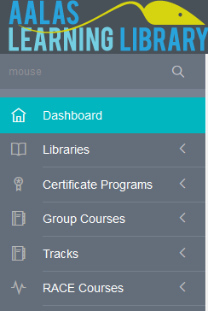

* The ALL “Dashboard” describes new courses and other ALL announcements or news.
  + Remember that ALL provides multiple types of online training to different institutions and *some of the features are NOT applicable to your account through UVA*.
* 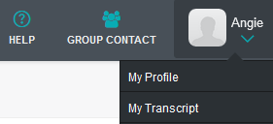“My Transcript” information is available regarding any courses you have started or completed within the ALL platform. The use of this information is only relevant if you complete *other recommended or certification training modules* as all required Animal Handler training will be automatically populated into your UVA Animal Handler Training Profile hourly.